- Dish Soap
- Tennis Balls
- Disposable Gloves
- Copy Paper
- File Folders
- Ink Pens
- Gallon Ziploc Bags
- Diamond Natural Dog food
- Clorox Wipes
- Clorox Foaming Cleaner
- 13 Gallon Kitchen Trash cans
- Pooper Scoopers
- 3-5 Gallon Buckets
- Large Trash Bags
- Paper Towels
- Toilet Paper
- Pig Ears
- Collars and leashes of all sizes
Pawsitive Warriors Rescue
Code:CX047

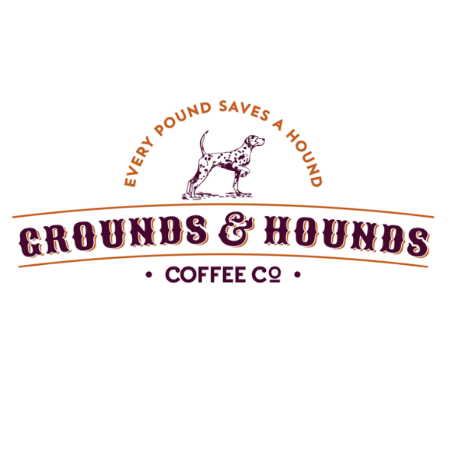https://groundsandhoundscoffee.com/discount/pawsitivewarriorsrescue15
https://www.chewy.com/rp/6473

- Kong’s
- Chew Toys
- Laundry Detergent
- Kitchen size Trash Bags
- Scrub Brushes
- Blankets
- Towels
- Elevated Pet Beds- Kuranda
- Slip Leashes
- Milk Bones

- OTHER _________________
_______________________
_______________________

Monetary donation $ _________
For: ________________________
____________________________
____________________________

